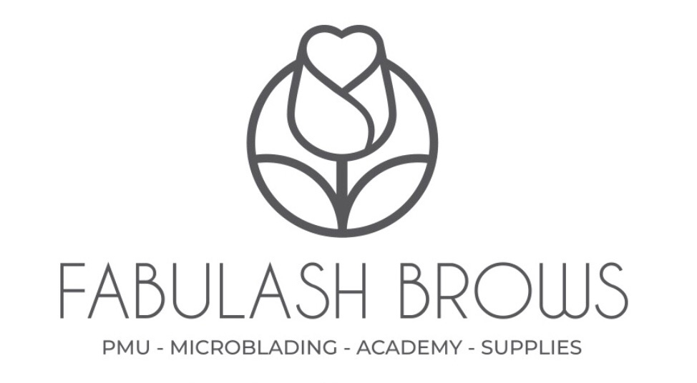

SEMI-PERMANENT MAKEUP DISCLAIMER

The SPMU technician will inform the client in detail about the treatment using suitable techniques and is obligated to perform the treatment in strict compliance with all hygiene and health protection methods.
Fabulash Brows SPMU technicians don’t touch up others’ work, an old tattoo will be treated as a new treatment. The client needs to send pictures of their old tattoos for consideration of the treatment methods. Microblading cannot be performed on dark tattooed eyebrows unless an old tattoo is removed or faded until very light. The client consent the technician to do SPMU treatment on his/her body and is aware of specific risks of the treatment. The following risks are specifically explained to the client:
- During the treatment, despite the staff's expertise and all the precautionary measures, the injury is possible.
- Despite the application of the most advanced and top-quality pigments, an allergic reaction is possible but rare. The client is informed about this and he/she assumes liability.
- A patch test can be done 48h prior to the treatment upon the customer’s requirement to test allergy ($50 fee applied).
- During and after the treatment, temporary swelling, redness, and/or itching may occur. Experience tells us that these symptoms are temporary.
- Depending on the skin structure and natural pigment, small scabs may occur and colour intensity may change. The fresh result before finally healing is up to 30-40% darker and 10-15% thicker. With microblading treatment, some drawn hairs might be lost after the first session.
- The shape is determined according to the face proportions. Symmetry is determined digitally, with closed eyes because of the negative impact of facial expression.
- The pigment is absorbed differently due to differences in the skin quality, thus there is no warranty for the treatment success.
- Depending on the skin structure it should be noted that change in the colour intensity is possible and that one or more additional treatments will be required.
- The minimum or maximum duration of SPMU treatment cannot be determined with certainty, nor can the warranty be given on performed treatment.
- The touch-up session is done within 4-6 weeks for eyebrows and eyeliners, and 8 weeks for lips. For oily and pigmented skin it is necessary to perform more corrections.
- SPMU always leads to skin injury. Therefore, it is important to carefully and gently nurture your skin after the treatment to allow healing without complications. Inadequate care in the healing phase of the skin can lead to poor results and the artist cannot be liable for it.
- The healing process takes 3-7 days and is different with each client. It is important to realize that a colour boost every (no prior to) 12-18 months is necessary to maintain a fresh appearance. Fading WILL happen after each procedure. We do not have control over your body’s healing process.

